CC-215-L: Database Systems Lab
BS(IT/CS) Morning - Fall 2023, Semester Spring 2023
LAB –11 (EVEN)
Instructor : Sir Asif Sohail
Time allowed : 90 mins
Task 01: _________________________ [9 Marks]
- Create a PL/SQL procedure department_report that uses a cursor to display each department's name, total employees, and total salary. 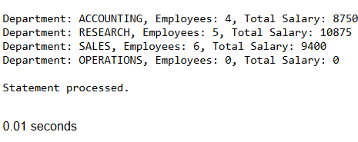

CREATE OR REPLACE PROCEDURE department_report
IS
CURSOR dept_cursor IS
SELECT dname, deptno
FROM dept;
v_dept_name dept.dname%TYPE;
v_deptno dept.deptno%TYPE;
v_count NUMBER;
v_total_salary NUMBER;
BEGIN
OPEN dept_cursor;
LOOP
FETCH dept_cursor INTO v_dept_name, v_deptno;
EXIT WHEN dept_cursor%NOTFOUND;
SELECT COUNT(*), SUM(sal)
INTO v_count, v_total_salary
FROM emp
WHERE deptno = v_deptno;
DBMS_OUTPUT.PUT_LINE('Department: ' || v_dept_name ||
', Employees: ' || v_count ||
', Total Salary: ' || NVL(v_total_salary, 0));
END LOOP;
CLOSE dept_cursor;
END;

BEGIN
DEPARTMENT_REPORT();
END;
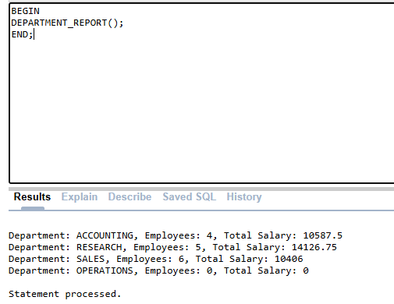

- Create a PL/SQL procedure SALARY_SHEET that receives empno as a parameter and prepares the salary sheet of an employee as per the following rules:
Medical Allowance: 10% of the salary
House Rent: 25% of the salary
Conveyance Allowance: 15% of the salary
Tax Deductions: 12% of the salary
The procedure should output the employee’s name, job, computed allowances, tax deductions, and net salary (salary after adding all allowances and subtracting Tax) all values in different variables.
You need to make variables to hold all these values
CREATE OR REPLACE PROCEDURE SALARY_SHEET (p_empno IN emp.empno%TYPE)
IS
v_ename emp.ename%TYPE;
v_job emp.job%TYPE;
v_salary emp.sal%TYPE;
v_medical_allow NUMBER;
v_house_rent NUMBER;
v_conveyance NUMBER;
v_tax_deduction NUMBER;
v_net_salary NUMBER;
BEGIN
SELECT ename, job, sal
INTO v_ename, v_job, v_salary
FROM emp
WHERE empno = p_empno;
v_medical_allow := v_salary * 0.10;
v_house_rent := v_salary * 0.25;
v_conveyance := v_salary * 0.15;
v_tax_deduction := v_salary * 0.12;
v_net_salary := v_salary + v_medical_allow + v_house_rent + v_conveyance -
v_tax_deduction;
DBMS_OUTPUT.PUT_LINE('Employee Name: ' || v_ename);
DBMS_OUTPUT.PUT_LINE('Job Title: ' || v_job);
DBMS_OUTPUT.PUT_LINE('Basic Salary: ' || v_salary);
DBMS_OUTPUT.PUT_LINE('Medical Allowance: ' || v_medical_allow);
DBMS_OUTPUT.PUT_LINE('House Rent: ' || v_house_rent);
DBMS_OUTPUT.PUT_LINE('Conveyance Allowance: ' || v_conveyance);
DBMS_OUTPUT.PUT_LINE('Tax Deduction: ' || v_tax_deduction);
DBMS_OUTPUT.PUT_LINE('Net Salary: ' || v_net_salary);
EXCEPTION
WHEN NO_DATA_FOUND THEN
DBMS_OUTPUT.PUT_LINE('Error: No employee found with EMPNO ' || p_empno);
WHEN OTHERS THEN
DBMS_OUTPUT.PUT_LINE('An unexpected error occurred: ' || SQLERRM);
END SALARY_SHEET;

BEGIN
SALARY_SHEET(7369);
END;
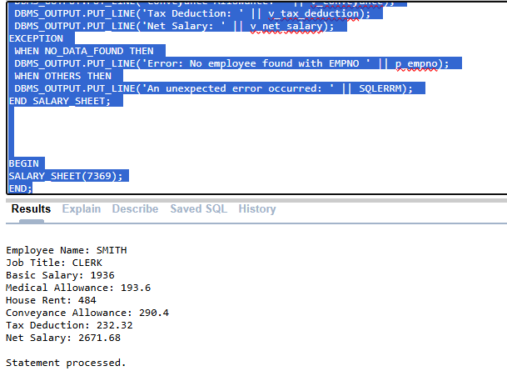

- Write a PL/SQL procedure named update_salary_by_10_percent that takes an employee number as input and increases their salary by 10%. The procedure should display the old salary, new salary, and handle cases where the employee does not exist.
CREATE OR REPLACE PROCEDURE update_salary_by_10_percent (P_EMPNO IN EMP.EMPNO%TYPE) IS
V_ENAME EMP.ENAME%TYPE;
V_SAL EMP.SAL%TYPE;
V_INC_SAL NUMBER;
BEGIN
SELECT ENAME,SAL INTO V_ENAME,V_SAL FROM EMP
WHERE EMPNO = P_EMPNO;
V_INC_SAL:= V_SAL+ (V_SAL*0.10);
DBMS_OUTPUT.PUT_LINE('EMP NAME : '||V_ENAME);
DBMS_OUTPUT.PUT_LINE('EMP OLD SAL : '||V_SAL);
DBMS_OUTPUT.PUT_LINE('EMP NEW SAL : '||V_INC_SAL);
EXCEPTION
WHEN NO_DATA_FOUND THEN
DBMS_OUTPUT.PUT_LINE('Error: No employee found with EMPNO ' || p_empno);
END;

BEGIN
update_salary_by_10_percent(7369);
END;
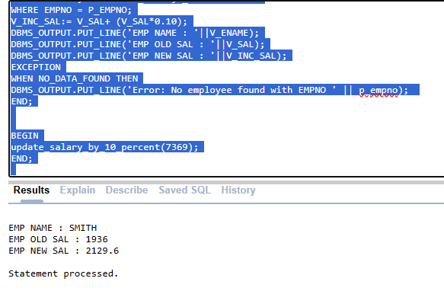
Task 01: _________________________ [18 Marks]
- Create PL/SQL function sal_status that takes both the salary of an employee and the department name as inputs and returns the salary is "above average salary" or "below average salary" based on the average salary of employees in the given department
CREATE OR REPLACE FUNCTION sal_status (p_sal in number,p_dname in varchar2)
RETURN VARCHAR2 IS
V_AVG NUMBER;
BEGIN
SELECT AVG(SAL) INTO V_AVG FROM EMP E
JOIN DEPT D
ON E.DEPTNO=D.DEPTNO
WHERE DNAME=P_DNAME;
IF p_sal > V_AVG THEN
RETURN 'LESS THAN AVG';
ELSE
RETURN 'GREATER THAN AVG';
END IF;
END;

declare
str varchar2(50);
begin
str:=sal_status(23000,'research');
dbms_output.put_line(str);
end;
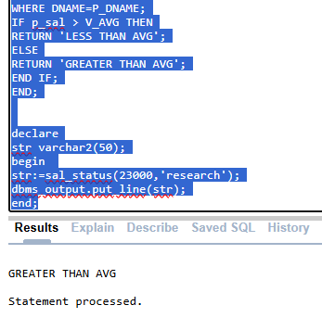

- Write a function named “GetSecondEmployeeByPriority” this should return the second number employee based on salary and hire date, giving priority to the hiredate while ensuring that the comm (commission) is not null.
Hint: You can use ROWNUM

CREATE OR REPLACE FUNCTION GetSecondEmployeeByPriority
RETURN EMP%ROWTYPE IS
V_EMP EMP%ROWTYPE;
BEGIN
SELECT *
INTO V_EMP
FROM
(SELECT * FROM EMP WHERE COMM IS NOT NULL ORDER BY HIREDATE,SAL DESC)
WHERE ROWNUM =2;
RETURN V_EMP;
END;

- Create a PL/SQL function find_dname(deptno number) that receives deptno as a parameter and returns the name of the department.
CREATE OR REPLACE FUNCTION find_dname(deptno IN NUMBER)
RETURN VARCHAR2 IS
v_dname VARCHAR2(50);
BEGIN
SELECT DNAME INTO v_dname
FROM DEPT
WHERE DEPTNO = deptno;

RETURN v_dname;
EXCEPTION
WHEN NO_DATA_FOUND THEN
RETURN 'Department Not Found';
END;

DECLARE
v_dept_name VARCHAR2(50);
BEGIN
v_dept_name := find_dname(10);
DBMS_OUTPUT.PUT_LINE('Department Name: ' || v_dept_name);
END;

- Create a trigger on the DEPT table that prevents the deletion of a department if the average salary of the employees in that department is greater than the average salary of all employees across all departments. If the condition is not met, allow the deletion and cascade the deletion to all employees in that department.
CREATE OR REPLACE TRIGGER prevent_dept_deletion
BEFORE DELETE ON dept
FOR EACH ROW
DECLARE
v_avg_salary_dept NUMBER;
v_avg_salary_all NUMBER;
BEGIN
SELECT AVG(sal)
INTO v_avg_salary_dept
FROM emp
WHERE deptno = :OLD.deptno;

SELECT AVG(sal)
INTO v_avg_salary_all
FROM emp;

IF v_avg_salary_dept > v_avg_salary_all THEN
RAISE_APPLICATION_ERROR(-20001, 'Deletion not allowed: Average salary in the department is greater than the global average salary.');
END IF;
END;
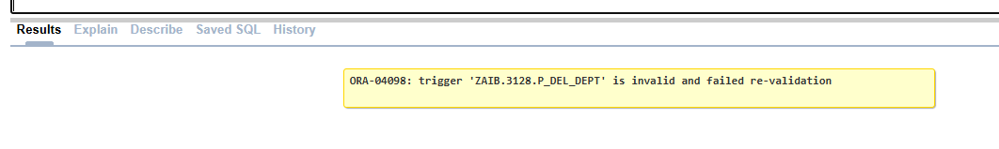
- Write a PL/SQL trigger named adjust_sal_on_conditions that adjusts the salaries of employees in a department whenever the department's location (LOC) is updated. Increase salaries by 20% if the new location is 'LONDON' and decrease salaries by 10% if the new location is 'CHICAGO'. Ensure the trigger applies the adjustment only if the department has more than 3 employees.
CREATE OR REPLACE TRIGGER adjust_sal_on_conditions
AFTER UPDATE OF loc ON dept
FOR EACH ROW
DECLARE
v_empno_count NUMBER; -- Variable to store the employee count
BEGIN
-- Count the number of employees in the department being updated
SELECT COUNT(*) INTO v_empno_count
FROM emp
WHERE deptno = :OLD.deptno;

-- Proceed if the department has more than 3 employees
IF v_empno_count > 3 THEN
-- Adjust salaries based on the new location
IF :NEW.loc = 'LONDON' THEN
UPDATE emp
SET sal = sal * 1.20
WHERE deptno = :OLD.deptno;
ELSIF :NEW.loc = 'CHICAGO' THEN
UPDATE emp
SET sal = sal * 0.90
WHERE deptno = :OLD.deptno;
END IF;
END IF;
END;

- Make a trigger update_sal that fires before the update of SAL in emp table of an employee with a specific EMPNO. The trigger should ensure that the raise in sal should not exceed 30% of the existing sal of the employees. In that case, the trigger should deny the update by raising an application error having message “SAL INCREASE CANNOT EXCEED MORE THAN 30 PERCENT”

Task 03: _________________________ [10 Marks]
- Create a PL/SQL function salary_encrypt that receives salary of the employees and encrypts the sal of an employee as per the following rules:
# is equivalent of thousands
@ is equivalent of hundreds
& is equivalent of tens
The digits 0,1,2,…,9 are replaced by a,b,c,…,j respectively.
Hint: translate('ab12cd34','abcd','wxyz;) = wx12yz34;
It is assumed that the sal can be up to 4 digits, and the sal is multiple of 10.
Examples:
Code for 4530: e#f@d&
Code for 8060: i#a@g&

